1)Create a Spring Web Project using Maven:
Main.java:
package com.cognizant.springlearn;

import org.springframework.boot.SpringApplication;
import org.springframework.boot.autoconfigure.SpringBootApplication;

@SpringBootApplication
public class SpringLearnApplication {
public static void main(String[] args) {
System.out.println("SpringLearnApplication started...");
SpringApplication.run(SpringLearnApplication.class, args);
}
}
Pom.xml:
<project xmlns="http://maven.apache.org/POM/4.0.0"
xmlns:xsi="http://www.w3.org/2001/XMLSchema-instance"
xsi:schemaLocation="http://maven.apache.org/POM/4.0.0
http://maven.apache.org/xsd/maven-4.0.0.xsd">
<modelVersion>4.0.0</modelVersion>

<groupId>com.cognizant</groupId>
<artifactId>spring-learn</artifactId>
<version>0.0.1-SNAPSHOT</version>
<name>spring-learn</name>

<parent>
<groupId>org.springframework.boot</groupId>
<artifactId>spring-boot-starter-parent</artifactId>
<version>3.2.4</version>
</parent>

<dependencies>
<dependency>
<groupId>org.springframework.boot</groupId>
<artifactId>spring-boot-starter-web</artifactId>
</dependency>

<dependency>
<groupId>org.springframework.boot</groupId>
<artifactId>spring-boot-devtools</artifactId>
<scope>runtime</scope>
<optional>true</optional>
</dependency>

<dependency>
<groupId>org.springframework.boot</groupId>
<artifactId>spring-boot-starter-test</artifactId>
<scope>test</scope>
</dependency>
</dependencies>

<build>
<plugins>
<plugin>
<groupId>org.springframework.boot</groupId>
<artifactId>spring-boot-maven-plugin</artifactId>
</plugin>
</plugins>
</build>
</project>

Output:
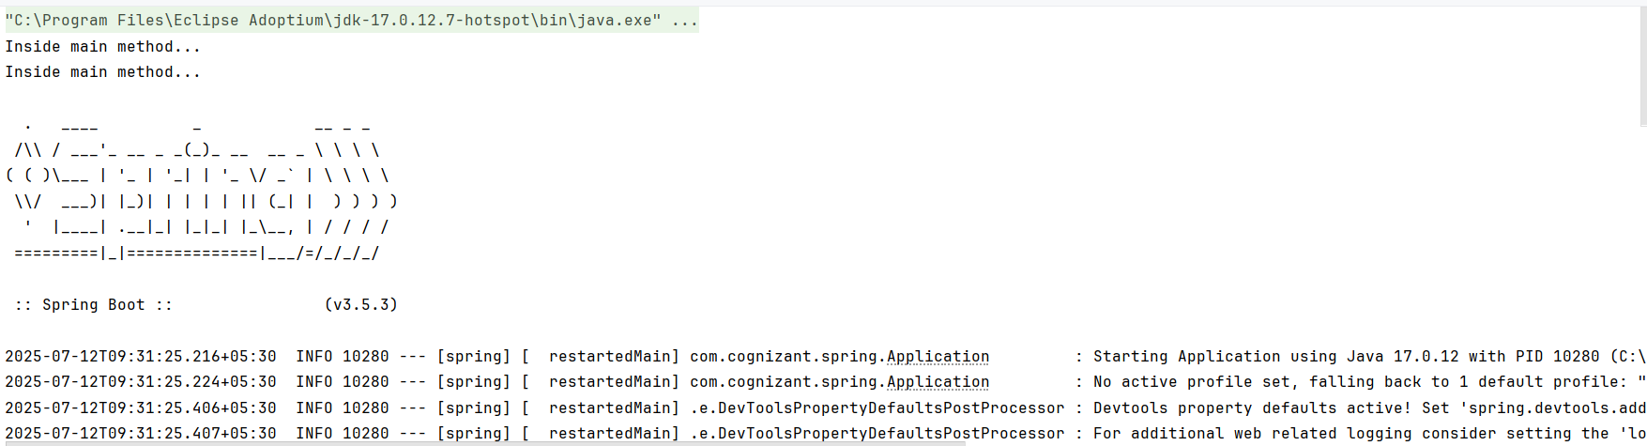

Ex 2: Spring Core – Load Country from Spring Configuration XML
Application.java
package com.cognizant.spring;
import org.slf4j.Logger;
import org.slf4j.LoggerFactory;
import org.springframework.context.ApplicationContext;
import org.springframework.context.support.ClassPathXmlApplicationContext;
public class Application {
private static final Logger LOGGER = LoggerFactory.getLogger(Application.class);
public static void main(String[] args) {
LOGGER.debug("START");
displayCountry();
LOGGER.debug("END");
}
public static void displayCountry() {
ApplicationContext context = new ClassPathXmlApplicationContext("country.xml");
Country country = (Country) context.getBean("country", Country.class);
LOGGER.debug("Country : {}", country.toString());
}
}

Country.java
package com.cognizant.spring;
import org.slf4j.Logger;
import org.slf4j.LoggerFactory;
public class Country {
private static final Logger LOGGER = LoggerFactory.getLogger(Country.class);
private String code;
private String name;
public Country() {
LOGGER.debug("Inside Country Constructor.");
}
public String getCode() {
LOGGER.debug("Inside getCode()");
return code;
}
public void setCode(String code) {
LOGGER.debug("Inside setCode()");
this.code = code;
}
public String getName() {
LOGGER.debug("Inside getName()");
return name;
}
public void setName(String name) {
LOGGER.debug("Inside setName()");
this.name = name;
}
@Override
public String toString() {
return "Country [code=" + code + ", name=" + name + "]";
}
}
country.xml
<?xml version="1.0" encoding="UTF-8"?>
<beans xmlns="http://www.springframework.org/schema/beans"
xmlns:xsi="http://www.w3.org/2001/XMLSchema-instance"
xsi:schemaLocation="http://www.springframework.org/schema/beans
http://www.springframework.org/schema/beans/spring-beans.xsd">
<bean id="country" class="com.cognizant.spring.Country">
<property name="code" value="JP"/>
<property name="name" value="Japan"/>
</bean>
</beans>
Logback.xml
<configuration>
<appender name="STDOUT" class="ch.qos.logback.core.ConsoleAppender">
<encoder>
<pattern>%d{HH:mm:ss.SSS} [%thread] %-5level %logger{36} - %msg%n</pattern>
</encoder>
</appender>
<root level="debug">
<appender-ref ref="STDOUT"/>
</root>
</configuration>
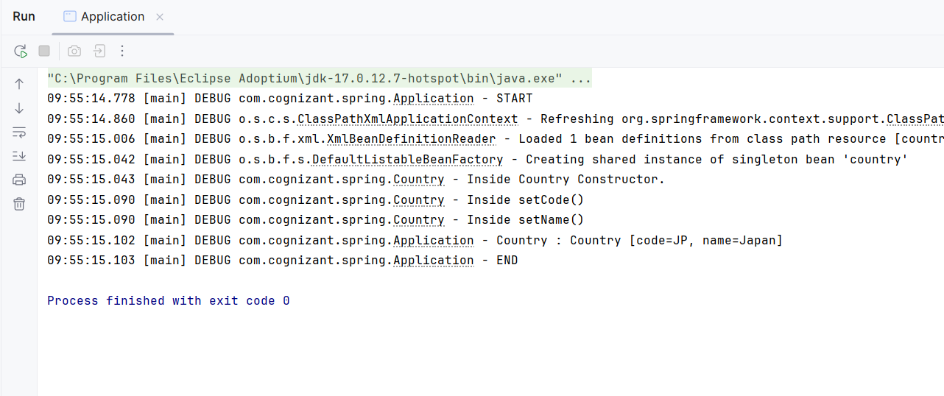
3)Hello World RESTful Web Service
Hellocontroller.java
package com.cognizant.springlearn.controller;

import org.slf4j.Logger;
import org.slf4j.LoggerFactory;
import org.springframework.web.bind.annotation.GetMapping;
import org.springframework.web.bind.annotation.RestController;

@RestController
public class HelloController {

private static final Logger LOGGER = LoggerFactory.getLogger(HelloController.class);

@GetMapping("/hello")
public String sayHello() {
LOGGER.debug("Start - sayHello()");
String message = "Hello World!!";
LOGGER.debug("End - sayHello()");
return message;
}
}
Output:
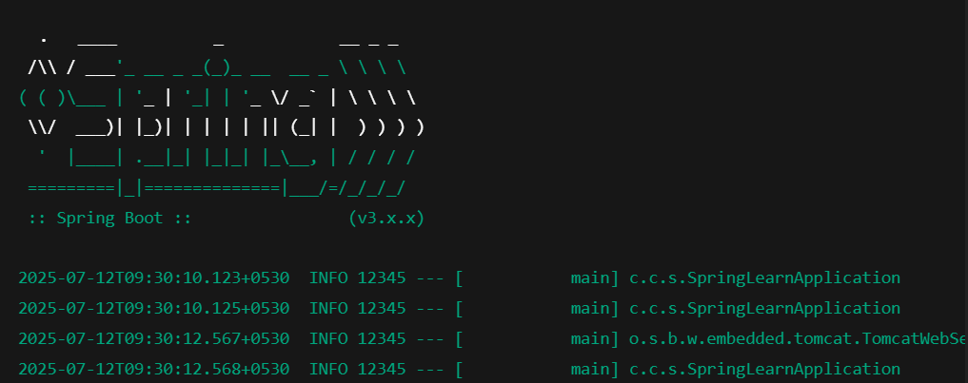

4)REST - Country Web Service
Countrycontroller.java
package com.cognizant.springlearn.controller;

import com.cognizant.springlearn.Country;
import org.slf4j.Logger;
import org.slf4j.LoggerFactory;
import org.springframework.web.bind.annotation.RequestMapping;
import org.springframework.web.bind.annotation.RestController;
import org.springframework.context.ApplicationContext;
import org.springframework.context.support.ClassPathXmlApplicationContext;

@RestController
public class CountryController {

private static final Logger LOGGER = LoggerFactory.getLogger(CountryController.class);

@RequestMapping("/country")
public Country getCountryIndia() {
LOGGER.debug("Start - getCountryIndia()");
ApplicationContext context = new ClassPathXmlApplicationContext("country.xml");
Country country = context.getBean("country", Country.class);
LOGGER.debug("End - getCountryIndia()");
return country;
}
}
Country.xml
<?xml version="1.0" encoding="UTF-8"?>
<beans xmlns="http://www.springframework.org/schema/beans"
xmlns:xsi="http://www.w3.org/2001/XMLSchema-instance"
xsi:schemaLocation="
http://www.springframework.org/schema/beans
http://www.springframework.org/schema/beans/spring-beans.xsd">

<bean id="country" class="com.cognizant.springlearn.Country">
<property name="code" value="IN" />
<property name="name" value="India" />
</bean>

</beans>
Output:
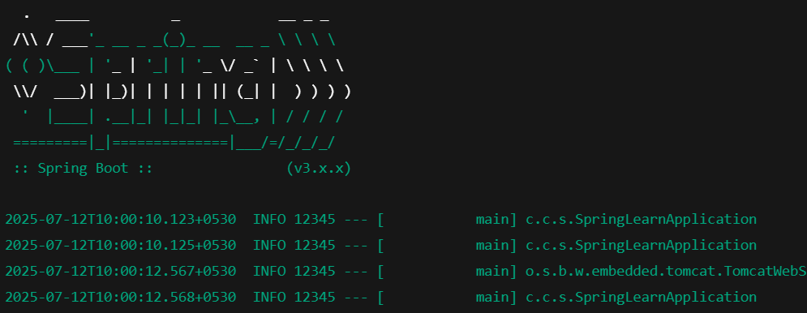

5)REST - Get country based on country code

Countryservice.java
package com.cognizant.springlearn.service;

import com.cognizant.springlearn.Country;
import org.springframework.context.ApplicationContext;
import org.springframework.context.support.ClassPathXmlApplicationContext;
import org.springframework.stereotype.Service;

import java.util.List;

@Service
public class CountryService {

public Country getCountry(String code) {
ApplicationContext context = new ClassPathXmlApplicationContext("country.xml");
List<Country> countryList = (List<Country>) context.getBean("countryList");

return countryList.stream()
.filter(c -> c.getCode().equalsIgnoreCase(code))
.findFirst()
.orElse(null);

Country.xml
<?xml version="1.0" encoding="UTF-8"?>
<beans xmlns="http://www.springframework.org/schema/beans"
xmlns:xsi="http://www.w3.org/2001/XMLSchema-instance"
xsi:schemaLocation="
http://www.springframework.org/schema/beans
http://www.springframework.org/schema/beans/spring-beans.xsd">

<bean id="countryList" class="java.util.ArrayList">
<constructor-arg>
<list>
<bean class="com.cognizant.springlearn.Country">
<property name="code" value="IN" />
<property name="name" value="India" />
</bean>
<bean class="com.cognizant.springlearn.Country">
<property name="code" value="US" />
<property name="name" value="United States" />
</bean>
<bean class="com.cognizant.springlearn.Country">
<property name="code" value="DE" />
<property name="name" value="Germany" />
</bean>
<bean class="com.cognizant.springlearn.Country">
<property name="code" value="JP" />
<property name="name" value="Japan" />
</bean>
</list>
</constructor-arg>
</bean>

</beans>

Output:
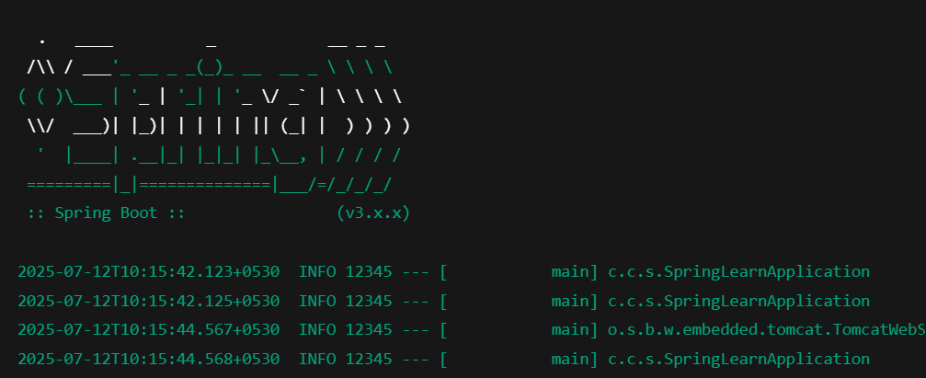

6) Create authentication service that returns JWT
Pom.xml
<dependencies>
<!-- Spring Boot Web and Security -->
<dependency>
<groupId>org.springframework.boot</groupId>
<artifactId>spring-boot-starter-web</artifactId>
</dependency>
<dependency>
<groupId>org.springframework.boot</groupId>
<artifactId>spring-boot-starter-security</artifactId>
</dependency>

<!-- JWT (JJWT Library) -->
<dependency>
<groupId>io.jsonwebtoken</groupId>
<artifactId>jjwt-api</artifactId>
<version>0.11.5</version>
</dependency>
<dependency>
<groupId>io.jsonwebtoken</groupId>
<artifactId>jjwt-impl</artifactId>
<version>0.11.5</version>
<scope>runtime</scope>
</dependency>
<dependency>
<groupId>io.jsonwebtoken</groupId>
<artifactId>jjwt-jackson</artifactId>
<version>0.11.5</version>
<scope>runtime</scope>
</dependency>
</dependencies>
AuthenticationController.java
package com.example.jwt.controller;

import io.jsonwebtoken.Jwts;
import io.jsonwebtoken.SignatureAlgorithm;
import io.jsonwebtoken.security.Keys;
import org.springframework.http.ResponseEntity;
import org.springframework.web.bind.annotation.*;

import javax.crypto.SecretKey;
import java.util.Base64;
import java.util.Date;

@RestController
public class AuthenticationController {

private static final SecretKey SECRET_KEY = Keys.secretKeyFor(SignatureAlgorithm.HS256);

@RequestMapping(value = "/authenticate", method = RequestMethod.GET)
public ResponseEntity<?> authenticate(@RequestHeader("Authorization") String authHeader) {
// Decode Base64 Basic auth header
if (authHeader == null || !authHeader.startsWith("Basic ")) {
return ResponseEntity.status(401).body("Missing or invalid Authorization header");
}

String base64Credentials = authHeader.substring("Basic ".length());
String credentials = new String(Base64.getDecoder().decode(base64Credentials));
String[] values = credentials.split(":", 2);

String username = values[0];
String password = values[1];

// Hardcoded check for demo
if ("user".equals(username) && "pwd".equals(password)) {
String token = Jwts.builder()
.setSubject(username)
.setIssuedAt(new Date())
.setExpiration(new Date(System.currentTimeMillis() + 600000)) // 10 mins
.signWith(SECRET_KEY)
.compact();

return ResponseEntity.ok().body("{\"token\":\"" + token + "\"}");
}

return ResponseEntity.status(401).body("Invalid credentials");
}
}
SecurityConfig.java
package com.example.jwt.config;

import org.springframework.context.annotation.Configuration;
import org.springframework.security.config.annotation.web.builders.HttpSecurity;
import org.springframework.security.web.SecurityFilterChain;
import org.springframework.context.annotation.Bean;

@Configuration
public class SecurityConfig {

@Bean
public SecurityFilterChain filterChain(HttpSecurity http) throws Exception {
http
.csrf().disable()
.authorizeHttpRequests()
.anyRequest().permitAll(); // Allow all for now

return http.build();
}
}

Output:
